Performance Shift Indicator Control Function – CGEA1.3

Functional Description
From version v5.0 Performance Shift Indicator menu is displayed on the Center Stack display and FBMP signals will be used as an interface between IPC and APIM.

This STSS maps the performance shift light modes based on user’s choice from the menu available in the Center Stack display. Each Performance Shift Indicator Item will have an associated graphic layout specified in a program specific Wallpaper file.

Once configured as Enabled at vehicle end-of-line through a DEXX bit, the Performance Shift Indicator offers customization options to the user that can be set via Center Stack settings menu. Performance Shift Indicator settings that are stored in cluster and shared with Sync when requested.

The different options available for the Performance Shift Indicator are:
RPM Shift Point (program defined range)
Performance Shift Tone (On/Off)
Performance Shift Mode (Off, Tach, Track, Drag)

The IPC Display Layout function correlates the Operational mode and Feature Based Messaging Protocol (FBMP) signals from APIM to activate the performance shift light modes.

Note: MyKey related functionality is not applicable for cluster.

Starting in MY18, the base Mustang program will display the Performance Shift Indicator as animations on the LX cluster (12.4” TFT display).

In addition, this STSS now also provides support to display Track Mode animation on the SX cluster (BX726ST, B479ST and C519ST ICA programs). There is no user menu for the Performance Shift Indicator on SX cluster. Instead, the animation is played based on pre-defined shift points determined by the program and only while in Track drive mode.

Interfaces

Interface Context Diagram (I/O Block Diagram)

Performance Shift Indicator Function Context Diagram

Inputs

IR-REQ-339492/C-INTERNAL:
- Operational_Mode
- Performance_Shift_Cfg – DEXX Configuration

MUX signal on the CAN Bus

SIG-REQ-339478/A-EngAout_N_Actl* Signal

Signal Name | Size  (bits) | Detail | Units | Res. | Offset | State  Encoded | Min. | Max.
EngAout_N_Actl | 13 |  | RPM | 2 | 0 |  | 0  (0x0) | 16382  (0x1FFF)

SIG-REQ-339479/B-EngAout_N_Dsply* Signal

Signal Name | Size  (bits) | Detail | Units | Res. | Offset | State  Encoded | Min. | Max.
EngAout_N_Dsply | 13 |  | RPM | 2 | 0 |  | 0  (0x0) | 16382  (0x1FFF)
*Note: A program will use only 1 of these 2 tachometer signals. Use the signal as defined in Tachometer Gauge STSS.

SIG-REQ-339480/B-CtrStkFeat2NoActl Signal

Signal Name | Size (bits) | Detail | Units | Res. | Offset | State  Encoded | Min | Max
CtrStkFeat2NoActl | 16 | - | Number | 1 | 0 |  | 0  (0x0) | 65535  (0xFFFF)

SIG-REQ-355931/B-CtrStkDsplyOp2_D_Rq Signal

Signal Name | Size  (bits) | Detail | Units | Res. | Offset | State Encoded | Min | Max
CtrStkDsplyOp2_D_Rq | 3 |  | SED | 1 | 0 |  | 0 (0x0) | 7 (0x7)
 |  | Null |  |  |  | 0x0
 |  | Query |  |  |  | 0x1
 |  | Set |  |  |  | 0x2
 |  | Upload |  |  |  | 0x3
 |  | Restore |  |  |  | 0x4
 |  | Copy |  |  |  | 0x5
 |  | Unused_1 |  |  |  | 0x6
 |  | Unused_2 |  |  |  | 0x7

SIG-REQ-413452/A-CtrStkFeat2ConfigActl Signal

Signal Name | Size (bits) | Detail | Units | Res. | Offset | State Encoded | Min | Max
CtrStkFeat2ConfigActl | 16 | - | Undefined | 1 | 0 |  | 0  (0x0) | 65535  (0xFFFF)

Outputs

IR-REQ-339495/C-Internal :
- Performance_Shift_RPM_Setup_Saved
- Performance_Shift_Tone_Setup_Saved
- Performance_Shift_Mode_Setup_Saved
- Performance_Shift_Chime_Status_Flag
- Performance_Shift_Animation

MUX signals on the CAN Bus

SIG-REQ-339467/B-FeatConfigIpc2Actl Signal

Signal Name | Size (bits) | Detail | Units | Res. | Offset | State  Encoded | Min | Max
FeatConfigIpc2Actl | 16 |  | Undefined | 1 | 0 |  | 0  (0x0) | 65535  (0xFFFF)

SIG-REQ-339468/B-FeatNoIpc2Actl Signal

Signal Name | Size (bits) | Detail | Units | Res. | Offset | State  Encoded | Min | Max
FeatNoIpc2Actl | 16 |  | Number | 1 | 0 |  | 0  (0x0) | 65535  (0xFFFF)

Function/Performance

F-REQ-339501/A-Operational Modes

Mode | Differentiating Vehicle Conditions
Sleep Mode | Performance Shift Indicator Displays Inactive
Limited Mode | Performance Shift Indicator Displays Inactive
Normal Mode | Performance Shift Indicator Displays Active/Inactive
Crank Mode | Performance Shift Indicator Displays Active/Inactive

Voltage Levels

Refer to the Cluster Features table located in the Operational Modes and Voltage Range Strategies Section in this SPSS.

Human-Machine Interface

Visual

Indicator Graphics / Display Format
Performance Shift Indicator menu is moved to Center Stack display from IPC. Center Stack Display will have below three settings. HUD related settings are no more applicable.
  - Shift Point set-up – RPM
  - Shift Tone
  - Shift Light Mode

Indicator Color Coordinates
Reference section COLOR & ILLUMINATION REQUIREMENTS (GRAPHICS)

Indicator Characteristics
Refer to Message Center X Display_Y Button Interface Section, where X and Y are appropriate values in this document.

HMI-REQ-339493/A-Audio

The Performance Shift Chime (Performance_Shift_Chime_Status_Flag) is requested per this STSS. Refer to F-REQ-339476 and F-REQ-339477.

Switch Control Logic

Not Applicable.

PFM-REQ-339500/A-System Accuracy

Within a 100msec of receiving a message that results in a change of state the cluster will update the display to the proper status.

Operation: Performance and Functional

Subsystem Algorithm Flowchart / State Diagram

F-REQ-339470/B-Performance Shift Indicator Configuration Flowchart

F-REQ-339471/C-IPC Display Layout Routine Flowchart

F-REQ-339476/B-Performance Shift Tone Activation Function

F-REQ-339477/B-Performance_Shift_Chime_Flag to Chime ID

Performance_Shift_Chime_Status_Flag | Chime ID
Active | Chime_6

F-REQ-355820/B-Performance_Shift_RPM_Setup based on FBMP

CtrStkFeat2NoActl  Signal | CtrStkDsplyOp2_D_Rq  Signal | CtrStkFeat2ConfigActl Signal | Performance_Shift_RPM_Setup_Saved
0x0D0F  (Shift Point set-up - RPM) | 0x2 (Set) | 0x0000  (0 RPM) | 0x0000  (0 RPM)
0x0D0F  (Shift Point set-up - RPM) | 0x2 (Set) | 0x0001  (100 RPM) | 0x0001  (100 RPM)
0x0D0F  (Shift Point set-up - RPM) | 0x2 (Set) | 0x0002  (200 RPM) | 0x0002  (200 RPM)
0x0D0F  (Shift Point set-up - RPM) | 0x2 (Set) | 0x003  (300 RPM) | 0x003  (300 RPM)
0x0D0F  (Shift Point set-up - RPM) | 0x2 (Set) | ….. | …..
0x0D0F  (Shift Point set-up - RPM) | 0x2 (Set) | 0x0050  (8000 RPM) | 0x0050  (8000 RPM)

F-REQ-339472/C-FeatConfigIpc2Actl State based on Performance_Shift_RPM_Setup_Saved

Performance_Shift_RPM_Setup_Saved | FeatConfigIpc2Actl  Signal | FeatNoIpc2Actl  Signal
0x0000  (0 RPM) | 0x0000  (0 RPM) | 0x0D0F  (Shift Point set-up - RPM)
0x0001  (100 RPM) | 0x0001  (100 RPM) | 0x0D0F  (Shift Point set-up - RPM)
0x0002  (200 RPM) | 0x0002  (200 RPM) | 0x0D0F  (Shift Point set-up - RPM)
0x003  (300 RPM) | 0x003  (300 RPM) | 0x0D0F  (Shift Point set-up - RPM)
….. | ….. | 0x0D0F  (Shift Point set-up - RPM)
0x0050  (8000 RPM) | 0x0050  (8000 RPM) | 0x0D0F  (Shift Point set-up - RPM)

F-REQ-339473/B-Performance_Shift_Tone_Setup status based on FBMP

CtrStkFeat2NoActl  Signal | CtrStkDsplyOp2_D_Rq  Signal | CtrStkFeat2ConfigActl Signal | Performance_Shift_Tone_Setup_Saved
0x0D10  (Shift Tone) | 0x2 (Set) | 0x0  (OFF/Disable) | 0x0  (OFF/Disable)
0x0D10  (Shift Tone) | 0x2 (Set) | 0x1  (ON / Enabled) | 0x1  (ON / Enabled)

F-REQ-339474/C-FeatConfigIpc2Actl State based on Performance_Shift_Tone_Setup_Saved

Performance_Shift_Tone_Setup_Saved | FeatConfigIpc2Actl  Signal | FeatNoIpc2Actl  Signal
0x0  (OFF/Disable) | 0x0  (OFF/Disable) | 0x0D10  (Shift Tone)
0x1  (ON / Enabled) | 0x1  (ON / Enabled) | 0x0D10  (Shift Tone)

F-REQ-355818/B-Performance_Shift_Mode_Setup status based on FBMP

CtrStkFeat2NoActl  Signal | CtrStkDsplyOp2_D_Rq  Signal | CtrStkFeat2ConfigActl  Signal | Performance_Shift_Mode_Setup_Saved
0x0D11  (Shift Light Mode) | 0x2 (Set) | 0x0 (OFF/Disable) | 0x0 (OFF/Disable)
0x0D11  (Shift Light Mode) | 0x2 (Set) | 0x1 (Tach) | 0x1 (Tach)
0x0D11  (Shift Light Mode) | 0x2 (Set) | 0x2 (Track) | 0x2 (Track)
0x0D11  (Shift Light Mode) | 0x2 (Set) | 0x3 (Drag) | 0x3 (Drag)

F-REQ-339475/B-FeatConfigIpc2Actl State based on Performance_Shift_Mode_Setup_Saved

Performance_Shift_Mode_Setup_Saved | FeatConfigIpc2Actl  Signal | FeatNoIpc2Actl  Signal
0x0 (OFF/Disable) | 0x0 (OFF/Disable) | 0x0D11  (Shift Light Mode)
0x1 (Tach) | 0x1 (Tach) | 0x0D11  (Shift Light Mode)
0x2 (Track) | 0x2 (Track) | 0x0D11  (Shift Light Mode)
0x3 (Drag) | 0x3 (Drag) | 0x0D11  (Shift Light Mode)

F-REQ-355858/B-Performance_Shift_Animation status based on different configurations

Performance_Shift_Mode  _Setup_Saved | Performance_Shift_RPM  _Setup_Saved | Performance_Shift_Animation
0x0 (OFF/Disable) | Don’t Care | No Animation
0x1 (Tach) | 0x0000 to 0x0050 | Tach Mode  (As per user selection for RPM)
0x2 (Track) | 0x0000 to 0x0050 | Track Mode  (As per user selection for RPM)
0x3 (Drag) | 0x0000 to 0x0050 | Drag Mode  (As per user selection for RPM)

F-REQ-413495/A-Performance Shift Menu Modes
The Performance Shift Indicator has 4 different user selectable Shift Light Modes (Off/Tach/Track/Drag). Each of these has a unique display animation that is played in the LX cluster.

Once Performance_Shift_Mode_Setup_Saved <> 0x0 (Off), the following modes shall become active on the display.
- Tach Mode
- Track Mode
- Drag Mode

F-REQ-341989/B-Performance_Shift_Mode_Setup_MC <> 0x0 (Off) :
Once Performance_Shift_Mode_Setup_MC <> 0x0 (Off), the following modes shall become active on the display.

Tach Mode

F-REQ-339510/A-Tachometer_Mode of Operation :
In Tachometer Mode, the cluster will read in engine RPM and perform a display animation. The animation illuminates linear, sequential graphics (color and comet tail) based on the engine RPM.

F-REQ-339511/B-Animation_Turn_On_shiftpoint :
The animation begins when the engine RPM reaches 1000 RPM’s below the user selected shift point. The Tach mode sequential animation begins when the engine RPM reaches the Performance_Shift_RPM_Setup_Saved – 1000 RPM

HMI of Tach mode in Normal view
The below is an example HMI of Tach mode in Normal view. It shows the amber marker for the user selected shift point at 2700 RPM, which is impossible since the minimum is 4000.

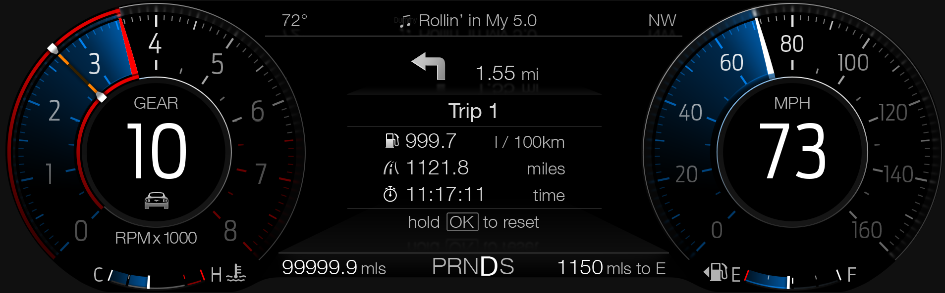

Track Mode

F-REQ-339513/A-Track Mode of Operation :
- In Track Mode, the cluster will read in engine RPM and perform a display animation. The animation illuminates linear, converging virtual LEDs based on the engine RPM and the user-selected shift point.

F-REQ-339512/B-Animation_Turn_On_shiftpoint :
As the engine RPM reaches the shift point, virtual LEDs from the left and right will converge in the middle. The animation will begin when the engine RPM increases to 2000 RPM’s below the user selected shift point. The Track mode sequential animation begins when the engine RPM reaches the Performance_Shift_RPM_Setup_Saved – 2000 RPM

F-REQ-339516/B-Continuous Animation_Operation :
The animation will continue in equal increments until it is complete when the engine RPM reaches the user-selected shift point (Performance_Shift_RPM_Setup_Saved).

F-REQ-339536/B-Animation on Over-Rev-Occurance :
When an over-rev occurs, the animations shall change. (Current direction is to flash red, follow HMI provided). An over-rev occurs when the engine RPM CAN signal is greater than the user-selected shift point by a Hysteresis Offset of 40 RPM. (Performance_Shift_RPM_Setup_Saved + Hysteresis_Offset).

F-REQ-339537/B-Over-Rev_Stop Condition :
If the engine RPM drops below the user-selected shift point (Performance_Shift_RPM_Setup_Saved), then the over-rev animation shall stop and the animation will display fewer virtual LEDs accordingly

HMI of Track_view

HMI_Trackview_user selected shift point is 6000 RPM :
The below is an example HMI of Track mode in Track view. The user selected shift point is 6000 RPM. The animation has just begun.

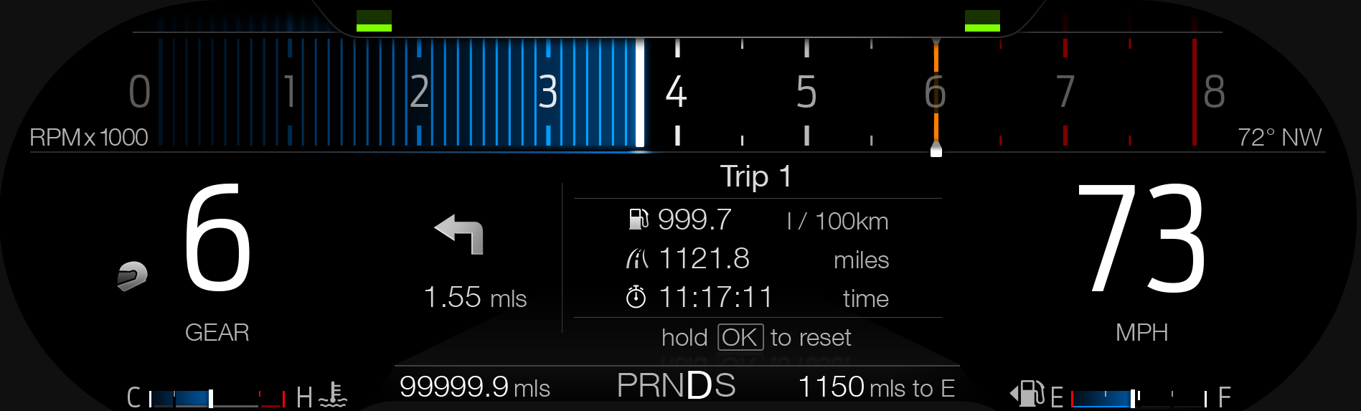

HMI of Track mode in Track view :
The below is an example HMI of Track mode in Track view. The user selected shift point is 6000 RPM. The animation has just completed. If this was accurate, the indicated tach would be at 6000 RPM instead of 3700 RPM.

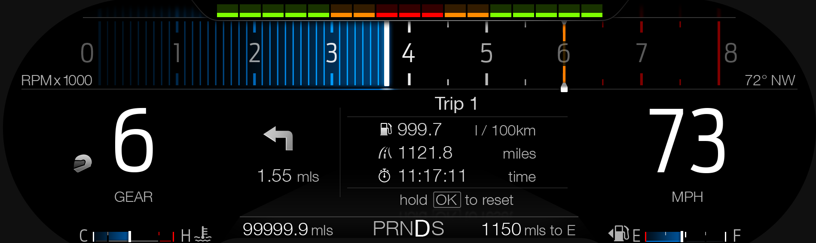

HMI of Track mode : Animation has switched to the over-rev condition :
The below is an example HMI of Track mode in Track view. The user selected shift point is 6000 RPM. The animation has switched to the over-rev condition. If this was accurate, the indicated tach would be at greater than 6040 RPM instead of 3700 RPM.

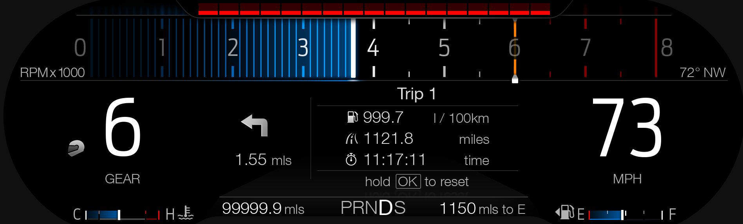

Drag Mode

F-REQ-339538/B-Drag Mode of Operation :
In Drag Mode, the animation illuminates all the virtual fill at once in amber when the engine RPM reaches the user-selected shift point

F-REQ-339539/B-Animation_Turn_On_shiftpoint :
Once the engine RPM decreases below the user-selected shift point (with
hysteresis), the animation turns off. he Drag mode animation turns on when the engine RPM reaches the user-selected shift point (Performance_Shift_RPM_Setup_Saved)

F-REQ-339540/B-Animation_Stop_Condition :
The animation will turn off when the RPM dips below a certain level defined by the following equation, where the Hysteresis offset is equal to 40 RPM: Performance_Shift_RPM_Setup_Saved - Hysteresis offset

HMI of Drag_Mode :
The below is an example HMI of Drag mode in Normal view. It shows the amber marker for the user selected shift point at 2700 RPM, which is impossible since the minimum is 4000.

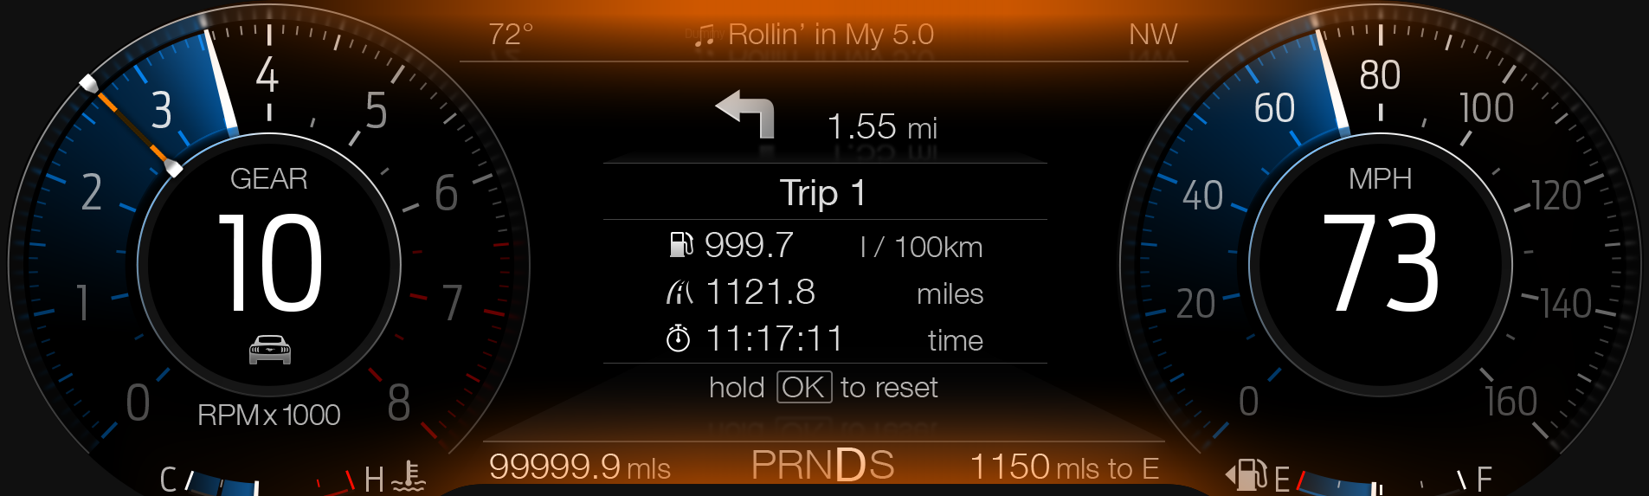

Operation Description (supports algorithm flowchart /state diagram)

F-REQ-339484/B-Activating the Shift Indicator Tone :

- The cluster, however, will activate the Shift Indicator tone based on F-REQ-339476.

F-REQ-339487/A-Performance Shift modes thru Ignition Cycles :

- All the Performance Shift modes shall be retained throughout ignition cycles.

F-REQ-339481/B-Menu Setting of Performance Shift Indicator :

Feature Name | Feature Num | Cfg Num | Cfg Value
Shift Point set-up - RPM | 0x0D0F | 0x0000 | 0 RPM
Shift Point set-up - RPM | 0x0D0F | 0x0001 | 100 RPM
Shift Point set-up - RPM | 0x0D0F | 0x0002 | 200 RPM
Shift Point set-up - RPM | 0x0D0F | 0x0003 | 300 RPM
Shift Point set-up - RPM | 0x0D0F | …
Shift Point set-up - RPM | 0x0D0F | 0x0050 | 8000 RPM
Shift Tone | 0x0D10 | 0x00 | OFF / Disabled
Shift Tone | 0x0D10 | 0x01 | ON / Enabled
Shift Light Mode | 0x0D11 | 0x00 | OFF / Disabled
Shift Light Mode | 0x0D11 | 0x01 | Tach
Shift Light Mode | 0x0D11 | 0x02 | Track
Shift Light Mode | 0x0D11 | 0x03 | Drag

F-REQ-339482/B-Performance Sift Indicator Menu on SYNC (For Reference)

Performance Shift | > | Shift Point | > | ▲
Indicator |  |  |  | 4500 RPM
 |  |  |  | ▼
 |  | Shift Tone | ◻
 |  | Shift Light Mode | > | Off | ●
 |  |  |  | Tach | ❍
 |  |  |  | Track | ❍
 |  |  |  | Drag | ❍

FS-REQ-339502/A-Function Safety Classification (EMC)

Class B

Memory Storage

NVM-REQ-339491/D-Function Parameters

Parameter Name | Description | Value at  Battery Connect | Value at  Module Wake-up
Performance_Shift_RPM_Setup_Saved | Output variable that saves the user selected cluster appearance view.  Parameter is to be stored in Battery Backed RAM. Parameter is stored in array Feature 0x0D0F[5]. | 0x0 | Do Not Init
Performance_Shift_Tone_Setup_Saved | Output variable that saves the user selected cluster appearance view.  Parameter is to be stored in Battery Backed RAM. Parameter is stored in array Feature 0x0D10[5]. | 0x0 | Do Not Init
Performance_Shift_Mode_Setup_Saved | Output variable that saves the user selected cluster appearance view.  Parameter is to be stored in Battery Backed RAM. Parameter is stored in array Feature 0x0D11[5]. | 0x0 | Do Not Init
Performance_Shift_Animation | Output variable that maps the cluster view based on user selection in center stack menu | 0x0 | Do Not Init
CtrStkDsplyOp2_D_Rq Signal | Input Signal to indicate Request Type. | NULL (0x0) | Do Not Init
CtrStkFeatNo2Actl Signal | Input signal sent from BCM to indicate Feature Number. | (0x0000) | Do Not Init
CtrStkFeatConfig2Actl Signal | Input signal sent from BCM to indicate current value of the feature setting for the feature that is being set or queried. | (0x0000) | Do Not Init
Cluster_Dsply_Settings_Menu_Cfg | Configures cluster to display items in the Settings menu (Set to “cluster” at cluster supplier manufacturer plant) | Use Stored Value | Use Stored Value
Performance_Shift_Chime_  Status_Flag | Output flag to the chime arbitrator | Inactive | Inactive
EngAout_N_Actl Signal | Input RPM signal from the PCM | 0 | Do Not Init
EngAout_N_Dsply Signal | Input RPM signal from the PCM | 0 | Do Not Init
Engine RPM | Refers to either EngAout_N_Actl signal or EngAout_N_Dsply signal. Only one signal applies to a given program, please refer to Tachometer Gauge STSS. | N/A | N/A
Performance_Shift_Cfg | State indicator for feature presence controlled via CAN at EOL at VO plant. Set to disabled at Cluster Supplier Manufacturing Plant | Use Stored Value | Use Stored Value
Operational_Mode | 4 state indicator for cluster operational mode | Limited | Limited, Normal or Crank
* Refer to Message Center X Display_Y Button Interface Section, where X and Y are appropriate values in this document.

Reconfigurable Telltale

None

Prove Out

Not applicable

Message Center Msg

Refer to program specific menu structure for appropriate display graphics.

Error Handling

Missing Message Strategy

Reference :
The signals will be declared missing as per the Diagnostics section of this SPSS.

DTCs states and history will be determined as per the Diagnostics section of this SPSS.

Diagnostics

Self Test

None

Engineering Test Mode

Reference section “Dealer / Engineering Test Mode (ETM)”

Part II Performance

DTC-REQ-339497/B-Supported Diagnostic Trouble Codes (DTCs)
Not Applicable.

DCR-REQ-339498/C-DID DEXX

Block  Num | Block Description | Size  (bits) | Type | Byte(s) | Bits | State: Description | "0" | "1" | Default | Comments/  Information
PACKETED BLOCKS
$XX | Option Content (B&A) | X | 1 | * | * | Performance Shift | Disabled | Enabled | Disabled | Determines if the feature is supported on a given program.
$0A | Option Content (B&A) | 1 |  |  |  | Cluster Display Settings Menu | Cluster | Center  Stack | Cluster | This parameter allows the few remaining cluster display settings menu items to be displayed in the cluster when 0x0. When 0x1, the expectation is that cluster display settings are displayed in the Centerstack. To be enabled on applications on which the cluster does NOT have any steering wheel switch inputs at all. (And thus cannot have any menus at all)  It is expected that DE09 Settings_Menu_Cfg will also be 0x1 on the rare case that this config is set to 0x1. (i.e. All settings are in Center Stack). Note this is a global config, each feature still has its own config for presence on vehicle.
*Byte and bit location to be identified in Part II Specification for this cluster

Reference Specification

None

Revision History
SPSS Module Revision History

Revision Level | Name | Change Description | Date
1.0 | V. Patel | Initial Release for 2015.75 S550 SVT cluster program.  Feature owners: Mike Makled, Zachary Nelson (SVT electrical team). | 1/13/2014
1.1 | V. Patel | An issue was found where while the Track apps menu was not displayed when the vehicle was driven using MyKey (per design), the cluster was still retaining the Performance shift settings from previous key cycle when the vehicle was driven using a non-MyKey key.  Introduced logic to fix the issue by requesting the HUD to turn OFF the Shift light mode on the output CAN signal as soon as MyKey is detected. The Shift point tone is deactivated in the cluster as well.  - Section 1.2.1, 1.2.2: Added Current_Ign_Key_Dev_Type as an input.  - Section 1.3.5.1,  - figure 3: Added decision diamond to transmit 0x0 on the HudMde_D_Rq signal when current key type is MyKey.  - Figure 4: Added decision diamond to deactivate chime status flag if current key is MyKey.  - Section 1.3.5.4: Added last bullet item. | 9/10/2014
1.2 | V. Patel | Changed the high point selectable RPM range from 8300 to 8200 as per direction from SVT team (Mike Makled).  Removed the use of OK button as confirmation to select the RPM range. Direction given by SVT team (Mike Makled, 9/19/2014) | 9/25/2014
1.3 | V. Patel | Update to clarify supplier question regarding the input to be used to determine if TracKey is active for this feature. Since it is a CAN input from BCM, the spec is updated to define it explicitly. There is no change to the functionality of the feature.  - Section 1.2.1, figure 1: Added the TracKeyMde_D_Stat Signal as an input.  - Section 1.3.5.1  - Figure 3, figure 4: Updated the diamond that checks for type of key used. Replaced the use of MyKey with Standard Key and TracKey inputs.  - Section 1.3.5.4: Added the TracKeyMde_D_Stat Signal as an input. | 12/16/2014
2.0 | S. Watkins | Major update for MY18 Base Mustang program. For the Base program with the LX cluster (12.4” TFT), the LED HUD is replaced with animation sequences in the cluster for Tach/Track/Drag modes. Thus, the base program does not send any CAN signals to the LED HUD. At this time, it is assumed that the SVT program will use both the LED HUD and the animation sequences on the cluster. Thus, this STSS has retained the CAN signals to the LED HUD as configurable for SVT program in MY19.  All changes highlighted in Green. Treat as new STSS. | 2/9/2016
3.0 | S. Watkins | Some minor changes based on direction from Keith Daugherty and team.  Scott, Ron,  Based on our review this morning, we have made decisions for the shift indicator. This should resolve our open items on the shift indicator. If you have any further questions/concerns let’s talk. Thanks.  - Tach Style: RPM offset  - New value = 1,000 RPM  - Current value = 2,000 RPM  - RPM Range for setting shift point  - New ranges  - I4: 4,000 – 6,400 RPM  - V8: 4,000 – 7,200 RPM  - Drag Style: Telltale  - Black outlines added to telltales  Keith Daugherty  Ford Motor Company  Mustang Vehicle Integration  Office: PDC, 1H-K65  Cell: 313-598-4871 E-mail: kdaughe1@ford.com  Changes as follows, marked in yellow:  - Section 1.2.1 – Figure 1 – Added Tach_Redline_Cfg  - Section 1.2.2 – Added Tach_Redline_Cfg  - Section 1.3.3.2 – Added scrolling ranges to HMI example.  - Section 1.3.5.1.1 – Table 1.6 – Added new column for Tach_Redline_Cfg. Also added Note 2 below table.  - Section 1.3.5.1.2.1 – Changed 2000 RPM to 1000 RPM for Tach Style.  - Section 1.6.3 – Added DExx for Tach_Redline_Cfg Tach Mode | 3/10/2016
3.1 | Ilopezla | Update to add Chime_Status_Flag associated with this warning in Audio Section  Section 1.3.3.3 Changed TBD to Performance_Shift_Chime_Status_Flag  Add Figure 4 and Table 1.11 Reference | 11/30/2016
3.2 | J.Arputha | - Section Number has been Updated to match the template.  - Initial VSEM RM Release | 1/08/2019
3.3 | V. Patel | A failure on my part to release a version in VSEM resulted in an older version being migrated to VSEM RM. This also resulted in a few changes never making it in the official VSEM document. This version captures all the missing requirements that have been implemented, but did not make it to VSEM until now.  - A new option has been added to the Performance Shift Mode menu, where the user can opt to choose the mode to change with the Selectable Drive Mode. Under this option, the Performance Shift mode follows Track and Drag modes, and is turned Off for all the other Drive modes.  - MY2020 EVO variants want to give the user a choice to select the display source for the Performance Shift Indicator via a menu in the cluster. The choices for display source are: Cluster (default) or the HUD.  All updates are in turquoise.  - Section 1.2.1: Added “SDM_Drive_Mode_Cmd” as an input and “Display_Source_Setup_MC” as a new menu item output.  - IR-REQ-339492: Added “SDM_Drive_Mode_Cmd” as an input to this feature.  - IR-REQ-339495: Add “Display_Source_Setup_MC” as an output variable  - Section 1.3.3.2: Modified example menu structure to show new item. Added notes below it for clarification.  - F-REQ-339471: Added a note in the title that the flowchart is applicable on non-EVO variants.  - F-REQ-355820: Created new flowchart to show which performance shift mode is requested based on SDM when user has chosen the “Change with Drive Mode” option.  - F-REQ-339472: Add a note below table clarifying that RPM ranges are defined in the menu structure.  - F-REQ-339474: Updated matrix to process the new user option.  - F-REQ-335858: Develop new matrix for the added “Display Source” item in the menu.  - NVM-REQ-339491: Added “Display_Source_Setup_MC” in the memory allocation table. Default is set to Cluster. Also added drive mode reference to the table. | 7/1/2019
4.0 | V. Patel | This update adds support to display Track mode animation on SX clusters.  DI CC approval: 6/17/2019 (offline by S. Watkins)  Requester: Biney-Amissah, Thomas (tbineya2@ford.com)  DI Tracking ID: 393  Lead program: Bx726ST  Updates are highlighted in orange.  - Title: Added “Ford Performance” to the STSS title. (no highlight for this one)  - 1.1: Add description for Performance Shift indicator animation on SX clusters.  - 1.2.1 Context Diagram: Added “ActvDrvMde_D2_Stat” as an input that is used to trigger the animation on SX clusters.  - SIG-REQ-355931: Added CAN signal definition for ActvDrvMde_D2_Stat.  - F-REQ-355932 – F-REQ-355937: Added requirements to display Track mode animations on SX clusters.  - 671209: Show examples of HMI animation graphic.  - NVM-REQ-339491: Add ActvDrvMde_D2_Stat in the table.  - DCR-REQ-339498: Changed description of the config parameter. | 7/23/2019
5.0 | H. Sharma | From version v5.0 Performance Shift Indicator menu is displayed only on the Center Stack display and FBMP signals will be used as an interface between IPC and APIM. Cluster programs which still have Performance Shift Indicator settings menu in cluster need to use version v4.0 of this STSS.  Although version v4.0 is used as baseline but Please treat version v5.0 as new STSS. Changed Text marked in Orange color (Previous color coding removed)  DICC Tracking # 676  Lead Program: S650  Change Requester: Daniel Menchaca. | 04/07/2021

